**IP Phones**

All phones were cleaned and all working in perfect condition

Directories are updated for all phones

All receive incoming calls

All receive outgoing calls

Weekly checklist is provided

Pictures of Cleaned phones

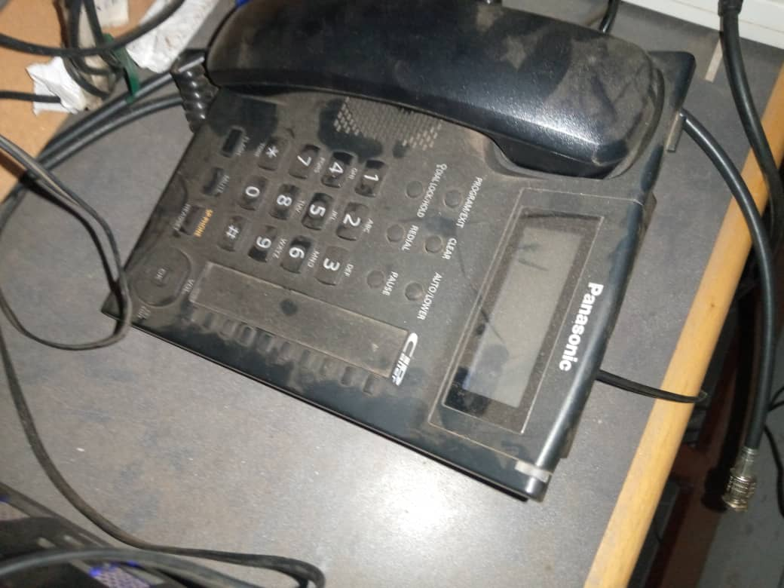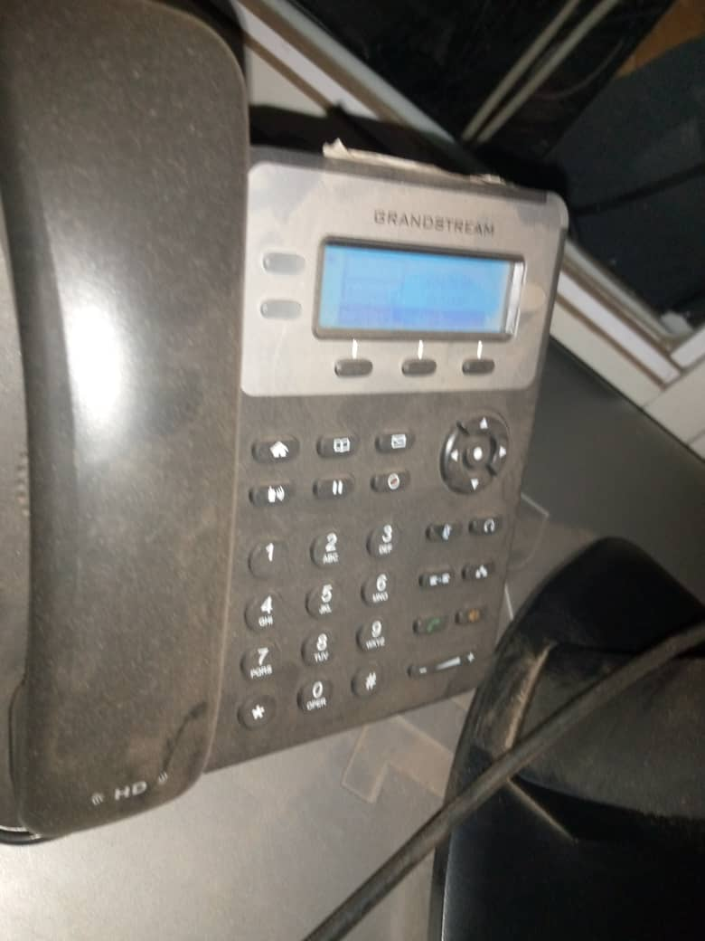**Before**

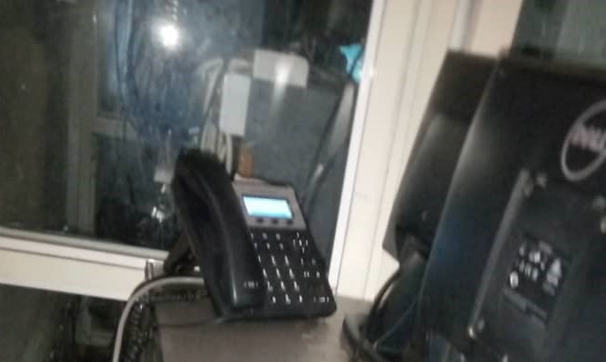

After